Yellow Class Newsletter
Summer 1
‘All Creatures Great and Small’
This half term we will be learning about all creatures, great and small! The children already have a wealth of knowledge about animals from home experiences and the experiences that we have here at school. Such experiences include; going to the zoo/farm, bug hotels, bug hunts and watching the life cycle of butterflies, tadpoles and stick insects.
Learning opportunities this half term include; interacting with ducklings, releasing the butterflies, a Pet Shop role play area and child initiated exploring!

Hand Writing / Fine Motor Skills
As your child’s fine motor skills develop, their hand writing and ability to form letters correctly will develop too! Please support your child at home to develop the small muscles in their hands and fingers so they can become effective writers. Here are ways that you can support your child!
Manipulating playdough, threading beads or pasta, using scissors to cut paper
If you would like more ideas, please do not hesitate to ask.

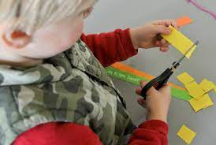
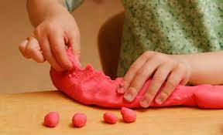
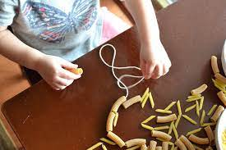

Home Learning
Children are to complete their phonics home learning sheet each week and stick it into their home learning book (its wonderful practise!). I would like the children to use their grapheme mat and tricky word chart to assist them with their word and sentence writing. If you have forgotten what this is, please ask.
Read 5 times per week and have their reading record signed by an adult.
Little Wandle book is read on a Wednesday and Thursday night, returned to school on Friday.
2 Reading for Pleasure books (1 phonics and 1 picture storybook) to be read over the weekend, Monday and Tuesday evening. Returned on Wednesday.
Though your child has set days to change books, please ensure that their books are in their bag EVERYDAY. This is best practise (and excellent for their development of responsibility!).
Complete an activity from the home learning grid and 20 minutes of Numbots.

Responsibility
In preparation for year 1, it is also important that we continue to support the children to develop their sense of responsibility.
In class, the children are asked to put their belongings away in their book bags, do up their own zips, change their own shoes etc. independently. It is vital that the children are encouraged to do these tasks by themselves at home too (this includes remembering their reading books, home learning books and water bottles on a school day!).
Resilience
As we move forward into the summer term, it is important that the children are continuing to develop their resilience and self-regulation skills. Resilience is one of our Morden values and it is important that we work together to develop this.
Ways that you can support your child to develop their resilience is by playing board games, risk taking/climbing activities and challenging puzzles. This also includes engaging in activities that are new for your child. This poses a challenge and allows them to develop their confidence.

Please remember, if you have any additional questions in regard to ways that you can support your child’s learning, please do not hesitate to ask.
Thank you for your ongoing support and we look forward to the summer term!
Miss Fursland, Miss Smith and Mrs Laslau.

