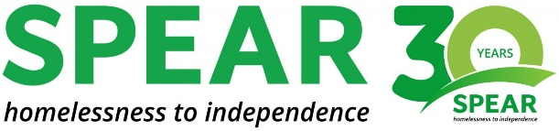

CHARITY CAKE SALE

Dear Morden Families,

Morden Primary School, with the help of the School Council will be raising money for the SPEAR homeless charity in Morden. This organisation helps homeless people become more independent and has been chosen by School Council as our focus charity to support this year.

To raise money, we will be having a bake sale after school on Tuesday 13th September. This is where we need your help. Please could you send in your donations of cakes, muffins, biscuits and cupcakes into school on Monday 12th September.

I know many Morden families are extremely talented bakers, so we are really looking forward to this fund-raising event!

Many Thanks,

Mrs P Barbour
PSHE Lead/Class Teacher

