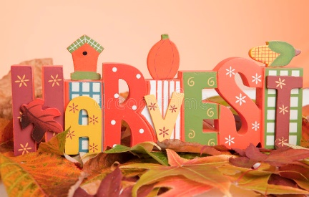

4th October 2022
Dear Parents and Carers

We are approaching a special time of year in our Morden Primary School calendar. Autumn is harvest time and a time to look out for local community, sharing food and friendship with the Friends of St Helier (FISH) organisation.

FISH is a charity that we have supported for the last few years and supports the older generation in our neighbourhood. It is a welcoming place that provides hot, home-cooked food with light entertainment, activities and most importantly companionship and friendship for people of a certain age.

From Monday 3rd October, we will be collecting tinned and long-life food products as part of our harvest collection. I am very pleased to say that Year 6 will deliver this to FISH on Thursday 20th October 2022. This is something we have missed doing over the last two years.

If you can spare any of the following items (well-dated), we would be really grateful.
Long-life milk (custard, etc)
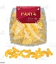
Pasta
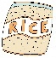
Rice
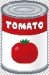
Tins (tomatoes, fruit, vegetables)
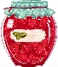
Jars (jams, marmalade, honey)

Thank you so much in advance.
Best wishes

Mrs Torreiro
Phase 3 Lead & Wider Curriculum Lead

