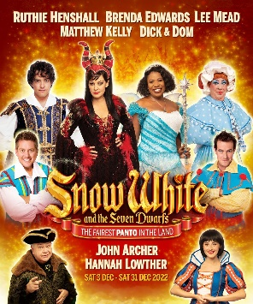

Thursda 10th November 2022

Dear Parent / Carers,

We are off to the Pantomime! Oh no you’re not……..oh yes we are to see Snow White and Seven Dwarfs at Wimbledon Theatre.
The theatre is a fantastic experience and one that we expect every child to enjoy during their time at Morden.
The seats are booked for Wednesday 7th December at 1pm. We will travel to Wimbledon on the train from Morden South and return the same way after the show has finished. Tickets are £15.50 and include an ice cream during the interval. This price is a massive saving on the standard cost. Seats are in the stalls so, by booking early, we have fantastic seats.

The running time has not yet been confirmed, but in the past, it has been approximately 2.5 hours

All children will need to bring in a packed lunch to eat before we leave on this day.

If you would like to book a seat, please complete the attached form and we will update your Parent Pay account.
Places will be allocated on a strict first come, first served basis.
All payments will need to be received by Friday 25th November. After this date, remaining places will be offered to children in KS1. No further tickets will be available so it's important you indicate your intent prior to this date. If full payment by this date is problematic, but you still wish your child to go, please speak with an office staff member.

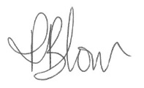
Yours sincerely,

Mrs P Blow
Headteacher

Pantomime – Wednesday 7th December 2022

I can confirm that I would like my child __________________________ of ______________ class
to attend the pantomime on Wednesday 7th December 2022 and will pay the full amount of
£15.50 by Friday 25th November.
I will supply my child with a packed lunch on this day [ ]

Signed _________________________________ Relation to child _____________________

Date ________________________

