5th October 2022

Dear Parents

I am pleased to share that Mrs Danaher is expecting her first baby in December.

Our top priority is to ensure our Year 3 children have a stable year with a strong teacher of Mrs Danaher’s calibre. We are acutely aware of the need of the children in this class due to their disrupted Reception and Year 1 due to covid. To this end, we will only settle for a good or outstanding teacher.

Recent recruitment proved unsuccessful, therefore the Senior Leadership team will take responsibility for teaching Year 3 in the second half of the Autumn term. Miss Diamant and Ms Doel will be job sharing the class from 31st October to Christmas.

We have readvertised for a two term position for the Spring and Summer terms. Parents will be kept informed of the process. The children are at the core of all our decisions.

I am sure you will join us in wishing Mrs & Mr Danaher the best of luck with their first baby as they enjoy this special time.

Yours sincerely

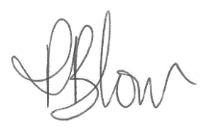

Mrs P.Blow
Headteacher

