5th January 2023

Dear Parents and Carers,

Morden Primary School Fund

What is the point of School Fund?
School Fund is an account which provides for many items in the school which enhance and enrich your child’s learning experiences at Morden Primary. Amongst other things, it is used to pay for reward stickers, certificates, competition and attendance prizes, Golden Time games and equipment, special art and display materials, seeds and gardening tools plus special books for the children.

We do not receive money in our main school budget to fund these extras.

How much is the school requesting?
This year we are asking parents and carers to choose an amount they would like to donate between £5 and £20 to cover the school year.

How can I make a payment?
A payment item will be added to your child’s ParentPay account. We cannot accept any cash/cheque payments directly to the school, if you need a ParentPay barcode letter to pay this amount at a local PayPoint shop, please let the school office know.

Remember, Morden’s School Fund is YOUR CHILD’S FUND.

Yours sincerely
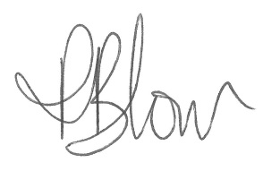

Mrs P Blow
Headteacher

