Red Class Home Learning 20th April – 25th May 2023
Dear Parents/Carers
This term’s learning is about the Kings and Queens in History and Plants in Science. I’ve included some fun creative, PE, music, research and investigative activities for you and your child to enjoy. Please remember that your child should be reading DAILY and at least 5 of these grid activities should be completed by the end of Half term. Thank you for your hard work…and enjoy.
PSHE/Music | Art | History | Science
What makes you Happy/Sad?  Make a poster/card of things that make you happy/sad. Draw some pictures and write the words. Share with your family and see if they agree with you. Challenge: Make a family poster! | Create your very own crown!!!  You can use anything shiny, card, paper, glue, plastic, pens and loads more to make your very own crown that you will need to wear when dressing up as a Monarch.  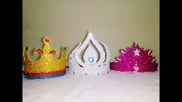 | Research time!  Who is our present day Monarch? What is the job of a Monarch? What would make a good Monarch?  Write 3 sentences to answer these questions. | What do plants need to grow?  Watch the video about what plants need to grow and then complete the quiz. Use the link below.  https://www.bbc.co.uk/bitesize/ topics/zpxnyrd/articles/zxxsyrd  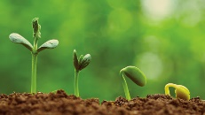
Design a musical instrument!  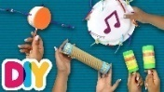  Find a container in your house that you can use to design your musical instrument e.g. cardboard tube, box, plastic bottle etc. Then ask an adult for some dried beans, rice etc. if you want to make a shaker. Find some tape and paper. Make and photograph your instrument. | My Nature Sculpture  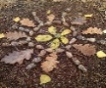  Have a look around your home, garden or park (if it’s safe to go there) then find some natural materials. Using these materials, design a sculpture that you could make with these objects. Name your sculpture and take a photo. | Dressing up time!  Imagine that you are the next in line to become the King or Queen. What rules and laws would you create?  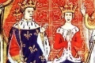  Share them with your family but you must dress up like a King or Queen before you present the rules and laws. | Grow your own plants!  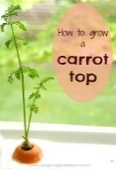  You can use the top of a carrot, beans, cress or any  Seeds to grow your  own fruit or veg.  Research what you’ll  need. It must be  easily available. Please  share your pics.
You are Unique!!!  Celebrate being Unique by doing a self-portrait and writing 3 reasons why you are unique- one of a kind!  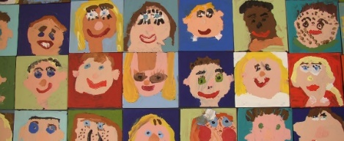 | Rainbow Fruit kebabs  Can you design your own fruit kebab? Plan which fruit you’re going to need, prepare it, describe it and examine fruit. Make the kebab by cutting up the different fruits-adult supervision needed. Taste and enjoy. Take a photo.  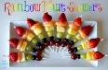 | Timeline!  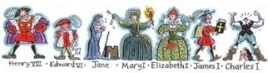  Can you make a Timeline of your family? Use paper to draw the timeline, starting with the oldest member of family and ending with the youngest OR if you have your family at home, then line them up in the correct timeline order and take a photo. | Plant diary  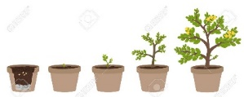  Can you keep a diary of your plant that you are growing? Use –  Day 1 Day 5  Planted the The shoot started  seeds. to grow.

