**Red Class Newsletter**

**Summer 1 2023**

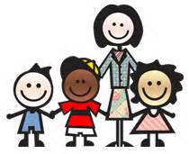

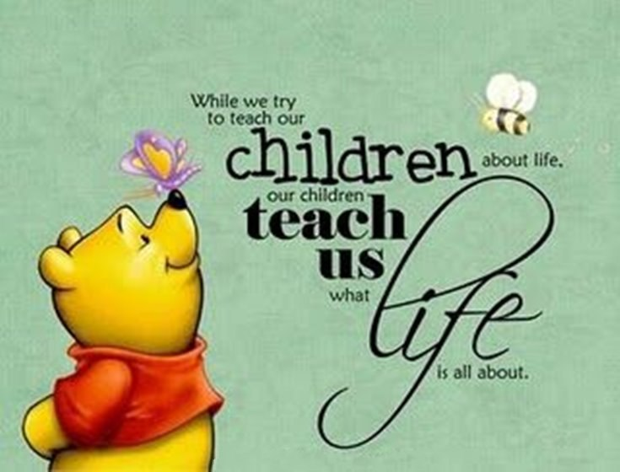

**Welcome back everyone!**

I hope that you have all had a lovely Easter break and are excited to start our learning this term.

In class

We have Mrs Messett as our Teaching Assistant and 1:1 support this term. In addition, Miss Doel will be teaching some lessons on Tuesdays.

Science [](https://www.google.co.uk/url?sa=i&url=http://www.t5fixtures.com/how-do-plants-grow/&psig=AOvVaw1xcW5jEKDf2LNsb0I9kKuC&ust=1586960070081000&source=images&cd=vfe&ved=0CAIQjRxqFwoTCJCkg5GN6OgCFQAAAAAdAAAAABAD)

Our Topic this term is **Plants.** We will be finding out how plants grow, parts of the plants and names of plants. We will observe and learn to ask and answer questions. We hope to enjoy planting and growing different plants in our class, as well as to experiment and record findings.

**P.E**.

P.E. will take place every **Monday** and **Thursday** and both sessions will be outdoors. P.E. kit will be worn all day.

PSHE/ RE

Our main focus for Summer 1 will be about Living in the Wider World and our Rights and Responsibilities. To understand and learn how to contribute to the life of the classroom and school. We will also focus on ‘What makes us unique’.

**History**

Our topic this term will be **Kings and Queens – The Monarchy.** This is a study of the monarchy to research, observe, handle and distinguish about the past. We will start to understand the historical terms such as monarch, parliament, government, war, remembrance and timelines.

[](https://www.google.co.uk/url?sa=i&url=http://picturemaps.co.uk/&psig=AOvVaw3Hpjuf63c5D4Dj2XiZ_zsa&ust=1586955660379000&source=images&cd=vfe&ved=0CAIQjRxqFwoTCJDV0er85-gCFQAAAAAdAAAAABAE)

**Home Learning**

Home Learning will be posted every Thursday on Google Classrooms. Your child will be expected to complete their task and upload it by the following Tuesday. This includes weekly Phonics, Numbots, a reading linked activity such as a comprehension and a termly range of topic themed tasks.

Reading must be done daily and an adult should sign the Reading record book. **Please ensure that your child has their reading books in their book bags daily.**

Thanks in advance for supporting your child with this.

Your child’s progress and emotional wellbeing are important to me; please make sure that you email me if you have any concerns about how your child is doing.

**I hope that we all have a fantastic term of learning.**

Thank you!

Mrs Smith