**Red Class Newsletter**

**Autumn 1 2022**

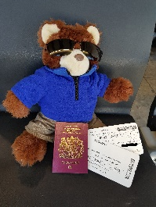

**Topic**

Our **Geography** topic this term will be **Our School.** This is a study of direction, mapwork and location. We will be observing the local area, looking at the features and using simple compass directions to draw a route on a map.

**Home Learning**

**Home Learning** will be posted every Thursday on Google Classrooms. Your child will be expected to complete their task and upload it to Google classroom on the following Tuesday. This includes weekly Phonics, a comprehension, Numbots (online resource for Maths) and a termly range of topic themed tasks. Uploaded topic learning will be shared each week in class.

(Log in details in Reading record book)

**Reading** should be done every day at home. This will greatly support your child’s progress this year!

All children will be provided with login details for the exciting online resources.

Thanks in advance for supporting your child with this.

**I hope that we all have a fantastic term of learning.**

Mrs Smith

**Hi,**

Welcome back everyone. I hope that you have all had a great Summer holiday with your children and that they are ready for the year ahead in Red class.

In class

We have Mrs Laslau as our Teaching Assistant and 1:1 support this year. In addition, Miss Doel will be teaching some lessons on Fridays.

Science

Our Topic this term is **Seasonal changes.** We will be finding out the different changes across the 4 seasons. We will observe and describe the weather and record data. We hope to enjoy a **Scavenger hunt** for **Autumn** objects in the park/garden.

**P.E.**

P.E. will take place every **Monday** and **Thursday** and both sessions will be outdoors. P.E. kit will be worn all day.

PSHE/ RE

Our main focus for Autumn 1 will be to ensure that all children are happy, healthy and feel a sense of belonging at school again.