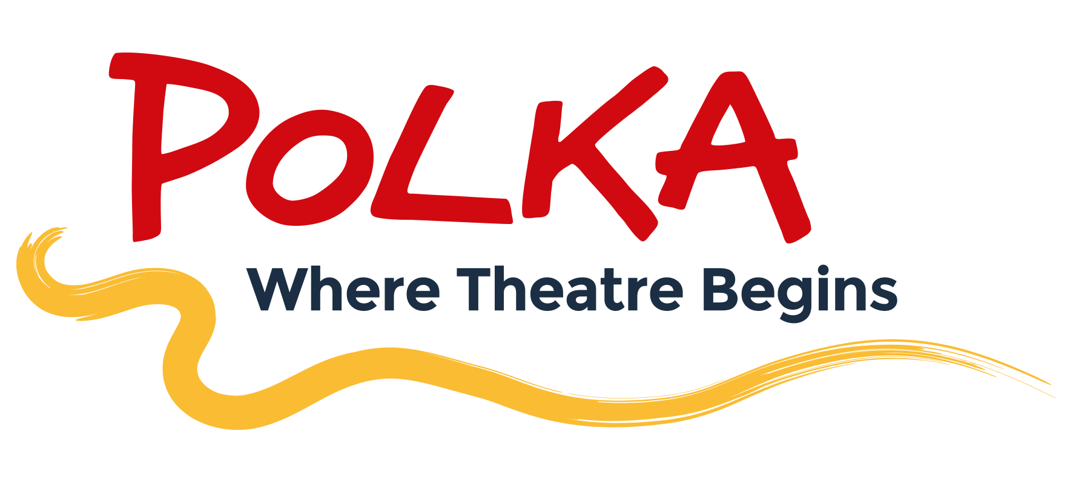

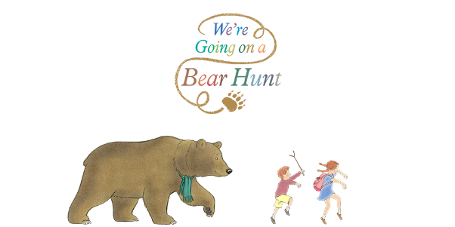
3rd October 2022

Dear Parent/Carers,

On Wednesday 12th October, Green Class will be visiting The Polka Theatre in Wimbledon to watch a performance of We’re Going on a Bear Hunt.

The cost of the trip is £10.00
We will be travelling by public transport and all children will be back to school in time for lunch.
Your child will need to wear full school uniform for this trip (no trainers) and a warm coat.

Please make payment, together with your consent for your child to attend this trip via our ParentPay system. Without full payment and consent, your child will not be able to attend this trip. However, we do not want any children to miss out on any educational school trips, so if you are having any financial difficulties please speak in confidence either with myself, your class teacher or Mrs Freeman.

Thank you for your ongoing support,

Ms D Hume
Year 2 class teacher

