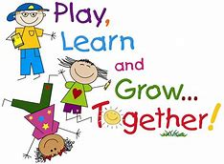

**Green Class Letter**

**Summer 2023**

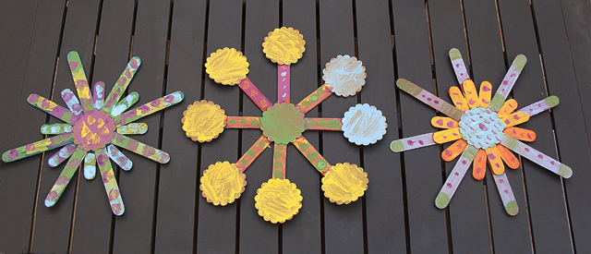

Dear Parents/Carers

I hope you had a lovely relaxing break and are feeling refreshed for the summer term ahead.

In class

We have Mrs Mann and Mrs Rajendran as our Teaching Assistants. In addition, Mrs Davies will be covering my release time for the first two weeks and then Mrs Rogers will take over for the rest of the half term.

Science

Our Topics this term is ‘Plants’ so the children will be given opportunities to grow their own plants and describe the stages in the life cycle of a

plant. They will be able to;

• Explain that plants need water, light and a

suitable temperature to grow well.

• Make observational drawings of plants.

• Measure the growth of plants with a ruler.

• Record the growth of plants in a bar

chart.

• Use observations to explain how we can tell

that plants are living things.

• Set up a simple comparative test.

• Make a simple prediction.

**Geography**

In geography we will be heading off to Kenya in our topic ‘Sensational Safari’.

Children will learn about the key geographical features of the country including Kenyan wildlife, landscapes and culture. Children will learn about the similarities and differences between Kenya and the UK along with continuing to develop their geographical skills through a variety of fun and interactive activities.

PE will take place every Thursday and Friday.

Your child will need to wear their P.E kit to school on these days.

Home Learning

Home learning will be set Thursdays and this will be a weekly task in maths and grammar which your child will complete in a text book. Please ensure home learning is handed in every Tuesday to be marked. Any late books will be marked the following week. There will also be 10 spellings to learn weekly with a spelling quiz every Thursday. There will be a home learning grid posted on google classroom. These are designed as fun activities for you to do with your child. Completed tasks will need to be uploaded on google classroom. I will also be sending home SATs maths revision packs for you to support your child. Please try to complete the activities.

Any home learning not completed at home may result in completion during break time.

It will still be an expectation for your child to read 5x per week and to use TT Rockstars daily. Reading books MUST now be in school every day. Please ensure they are kept in your child’s book bag.

Thanks in advance for supporting your child with this.



**I hope we all have a fantastic term of learning. Please look out for letters about trips coming up.**

Mrs Hume

***PS Please make sure your child is in school on time and brings in a water bottle. Thanks!***