2

**Blue Class Newsletter – Spring 1**

**HOME LEARNING**

For this half term we will continue **not to** use Google Classrooms. You will soon receive a pack of Home Learning information – please read this carefully as children will have to complete any incomplete work during their lunch break.

Maths and Comprehension

Maths and Comprehension workbooks will be sent home every Thursday and will be expected back in school on a Tuesday so that we can mark them together.

Spellings

Weekly spellings will be tested on Fridays.

Reading

Reading should be done daily at home. This half term your child will be bringing home 2 books. All reading books **must be** in every Monday and Thursday. Reading diaries should be in school every day so that we can sign them when we read with your child.

Times Tables

Times tables learning should be done every day at home through Times Tables Rock Stars and they will be tested every Monday.

**TOPIC GRID**

In the home learning pack, there will be a half termly topic grid. These activities should be completed across the half term and handed in on Monday 6th February.

Thanks in advance for supporting your child with this and if you have any questions, please do ask.



Mr Olaniran

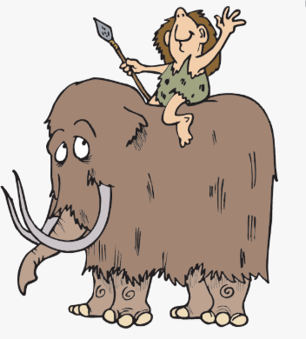

Dear Parents/Carers

I am really looking forward to this half term in Blue Class and very excited to be joining the Morden Primary team to help your children develop as successful learners. Please do not hesitate to come and speak to me if you have any questions.

In class

We have Mrs. Flint and Mr. Smith as our Teaching Assistants this term. In addition, Mrs. Green will be teaching Maths groups and Miss Diamant will be teaching Literacy groups.

Science

Our Topic this term is Animals Including Humans. We will be looking at nutrition, as well as how skeletons and muscles are used for protection and movement.

P.E.

P.E. will continue to take place every Wednesday and Friday and P.E. kit will be worn all day. Please remember that all long hair must be tied back and earrings are either removed or taped over for health and safety reasons.

Topic

Our History this half term will be the Romans!

Literacy and Maths

Three times a week, we will continue to split into 2 groups for Literacy and Maths.