2

**Blue Class Newsletter – Summer A**

**HOME LEARNING**

For this half term we will only be using Google Classrooms for PowerPoint Projects. You will soon receive a pack of Home Learning information – please read this carefully as children will have to complete Maths, Spellings, Grammar and the grid. Any incomplete work will be done during their lunch break.

Maths and Comprehension

Maths and Grammar workbooks will be sent home every Thursday and will be expected back in school on a Tuesday. We will mark them together.

Spellings

Weekly spellings will be tested on Fridays.

Reading

Reading should be done daily at home (20 mins minimum). This half term your child will be bringing home 2 books. All reading books **must be** in everyday. Reading diaries should be in school every day so that we can sign them when we read with your child.

Times Tables

Times tables learning should be done every day at home through Times Tables Rock Stars and they will be tested every Monday.

**TOPIC GRID**

In the home learning pack, there will be a half termly topic grid. These activities should be completed across the half term and handed in on Tuesday 23rd May 2023.

Thanks in advance for supporting your child with this and if you have any questions, please do ask.



Mr Olaniran

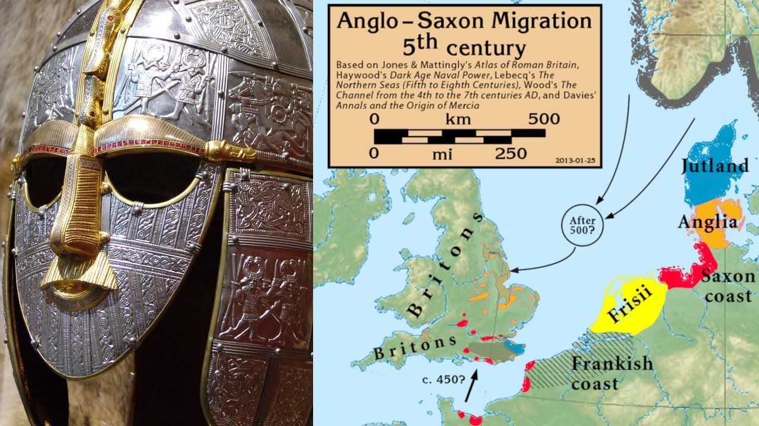

Dear Parents/Carers,

We are eager to begin this half term in Blue Class. The Morden Primary team is excited to help your children develop as successful learners.

In class

We have Mrs. Flint and Mr. Smith as our Teaching Assistants this term. In addition, Mrs. Green will be teaching Maths groups and Miss Diamant will be teaching Literacy groups.

Science

Our Topic this term is Light. We will be conducting experiments and be writing up our investigations as scientifically as possible.

P.E.

P.E. will continue to take place every Wednesday and Friday. P.E. kits will be worn all day. Please remember that all long hair must be tied back, earrings are either removed or taped over for health and safety reasons and footwear must be correct. We are learning Athletics & Tennis.

Topic

Thank you for all your help with the amazing projects the children brought in last term. Our History topic this half term will be Anglo-Saxons and Celts!

Literacy and Maths

Three times a week, we will continue to split into 2 groups for Literacy and Maths. We will be looking at poetry