**Purple Class Newsletter**

**Summer 1 2023**

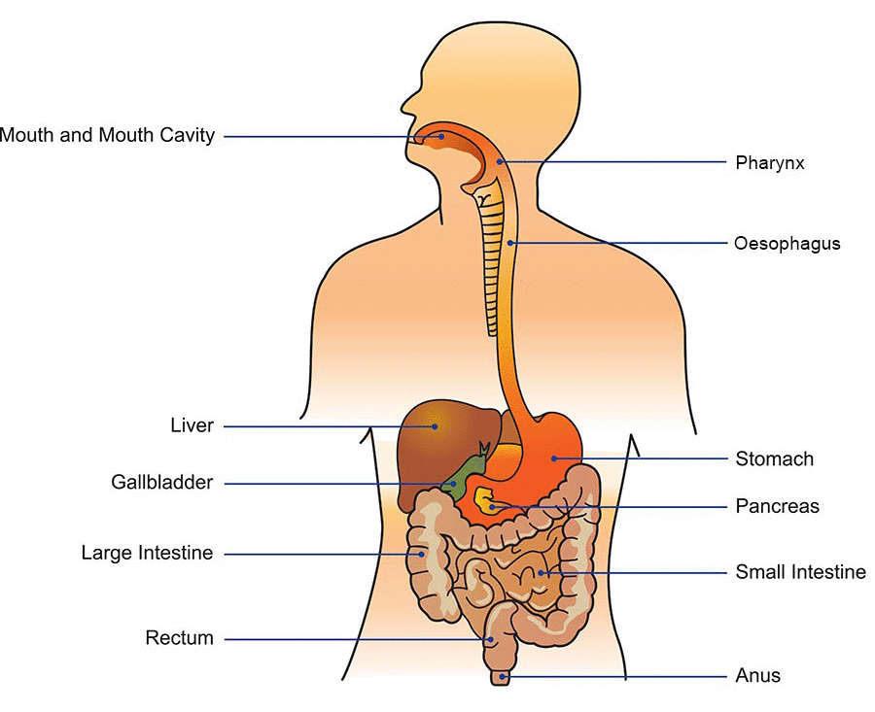

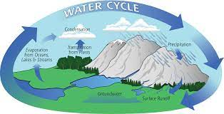

**Hi,**

Welcome back to the first half of our Summer term. I hope you had a lovely half term break.

In class

Mrs Davies will now be teaching with me and Mrs Dorrian is our Teaching Assistant.

Science

In Science we will be learning about ANIMALS INCLUDING HUMANS. We will be investigating the functions of teeth and how our digestive system works

**Topic**

Our Topic focus is Geography this half term and the theme is **‘WATER’**. We will be looking at the water cycle and how water gets treated before it comes into our homes.

**PE**

PE will take place every **Wednesday and Thursday** and our focus is Gymnastics and Tennis. **Please ensure your child comes in to school wearing their PE kit on Wednesday and Thursday.**

**Home Learning**

Children are expected to read 5 x per week. **Please ensure your child brings in their accelerated reading book and their reading for pleasure book in everyday, with their Reading Record too.**

They will be expected to complete all their tasks on Google Classroom. There will be a half term grid linked to our Geography topic. Please complete one task each week.

Children will be expected to access **ttrockstars** for Maths. They will also get weekly spellings on Google Classroom.

At the end of Year 4 the children will need to know all the x tables up to 12.



**Thanks in advance for supporting your child.**

**Mrs Barbour**

***PS Please make sure your child is in school on time. Thanks!***