2nd November 2022

Dear Parent/Carers,

To celebrate the Into Film Festival Year 3 and Year 4 have been given free tickets to watch ‘Sing 2’ on Thursday 24th November at Cineworld Wandsworth.

This is a free event.

We will be travelling by public transport so please ensure your child has a warm coat and is wearing full school uniform for this trip (no trainers).

All children will need a packed lunch.

If you receive free school meals and would like to order a school packed lunch, please email the school at info@morden.merton.sch.uk
Please make sure you include your childs name, class and what the school trip they need the packed lunch for. The last day to order a school packed lunch is Wednesday 9th November.

We really need two parent helpers for this trip. If you are able to give up your time please email the school office.

Yours sincerely,

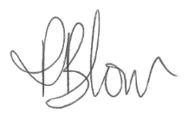

Mrs P.Blow
Headteacher

