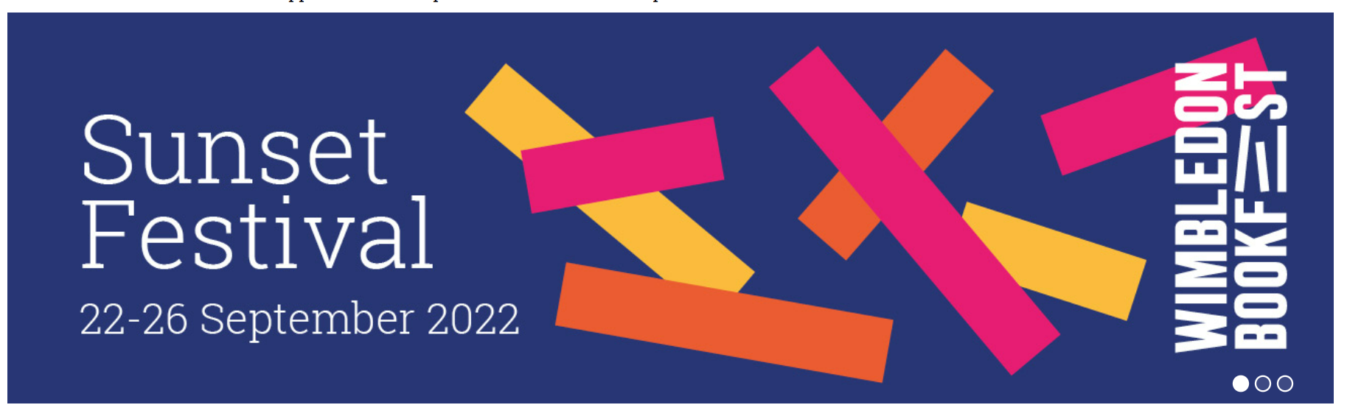

Friday 16th September 2022
Dear Parents and Carers,

Over the month of September, years 3, 4 and 5 will be visiting the Wimbledon BookFest on Wimbledon Common and New Wimbledon Theatre, attending a workshop with a participating author. During each event, children will get the chance to hear the author talk about their book, their inspirations and the secrets behind successful writing. In addition to this, all children will receive a copy of their author’s book!

The cost of the trip is £12.50 and we will be travelling by bus.

- Year 3 – Friday 23rd September 2022, 1:30-2:30pm - MICHAEL MORPURGO & the KANNEH-MASON FAMILY- Carnival of Animals
- Year 4 – Thursday 29th September 2022, 10:00-11:00am, NOEL FITZPATRICK- Vetman
- Year 5 – Thursday 29th September 2022, 2:00 – 3:00pm– MG LEONARD & SAM SEDGMAN- The Arctic Railway Assassin

Please note that year 3 will be returning by 3:30pm and year 5 will be returning by 4pm. Please collect your children from in front of the Studio, unless they have permission to walk home.

Your child will need to wear full school uniform for this trip (no trainers), a coat (please check the weather forecast on the day) for the journey and bring a packed lunch with a water bottle that can be refilled.

Please make payment, together with your consent for your child to attend this trip via our ParentPay system by Friday 23rd September. Without full payment and consent, your child will not be able to attend this trip. However, we do not want any children to miss out on any educational school trips, so if you are having any financial difficulties please speak in confidence either with myself, your class teacher or Mrs Freeman.

Many thanks,

Mrs Danaher
Phase 2 Lead & Literacy Lead

