20th February 2023

Dear Parents and Carers,

On Thursday 9th March, Year 4 will be visiting Wimbledon Bookfest to meet the author, Francesca Simon and illustrator Steve May.
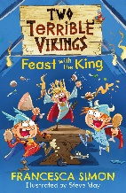
Many of the children will know Francesca as the author of the Horrid Henry books.

All children will be given a copy of her latest book, Feast with a King.

The cost of this trip is £12.50 – please make payment via Parent Pay.

We will travel to Wimbledon theatre by public transport and will be back at school for the end of the school day at 3:10pm. Please ensure your child has a warm coat and is wearing full school uniform for this trip (no trainers).

All children will need a packed lunch.

If you receive free school meals and would like to order a school packed lunch, please email the school at info@morden.merton.sch.uk
Please make sure you include your child’s name, class and what the school trip they need the packed lunch for. The last day to order a school packed lunch is Friday 24th February.

Kind Regards,

Mrs P Barbour
Year 4 Class Teacher

