**Purple Class Newsletter**

**Spring 2023**

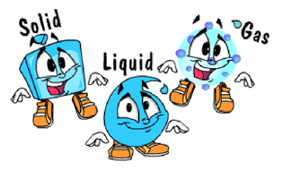

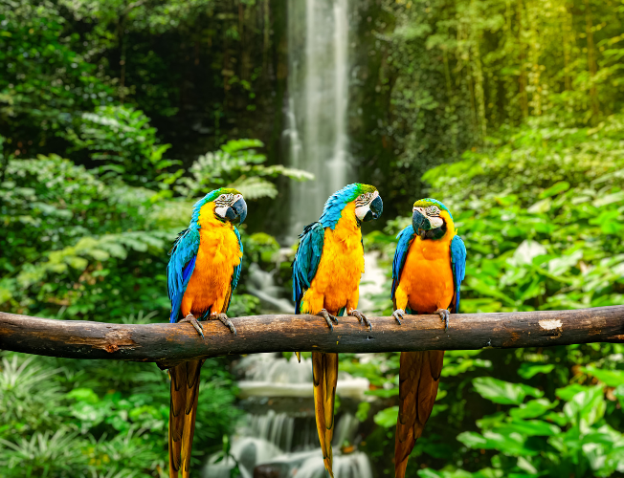

**Hi,**

Happy New Year to you all. I hope you have had a lovely holiday.

In class

Mrs Davies will now be teaching with me and Mrs Dorrian is our Teaching Assistant.

Science

Our Topic this half term is **States of Matter.** We will be leaning about solids, liquids and gases and the properties of each. We will be finding out if a gas has weight and why liquids flow at different speeds.

**Topic**

Our Topic focus is Geography this half term and the theme is **‘Rainforests**. We will be looking at the location of rainforests around the world. The children will learn the importance of these areas and how they help stop climate change.

**PE**

Outdoor PE will take place every **Wednesday and Thursday** and our focus is Netball and Tag Rugby. **Please ensure your child comes in to school wearing their PE kit on Wednesday and Thursday.**

**Home Learning**

Children are expected to read 5 x per week. They will be expected to complete all their tasks on Google Classroom.

There will be a half term grid linked to Geography, Science and PSHE. Please complete one task each week.

Children will be expected to access **ttrockstars** for Maths. They will also get weekly spellings on Google Classroom.

At the end of Year 4 the children will need to know all the x tables up to 12.

Thanks in advance for supporting your child with this.



**I hope we all have a fantastic term of learning.**

**Mrs Barbour**

***PS Please make sure your child is in school on time. Thanks!***