**Purple Class Newsletter**

**Autumn 2022**

**Topic**

Our Topic focus is Geography this half term and the theme is **‘ALL AROUND THE WORLD’**. We will be looking at the location of different countries around the world.

**PE**

Outdoor PE will take place every **Tuesday** and our focus is football **Please ensure your child comes in to school wearing their PE kit on Tuesday.**

**Swimming** will begin on the 19th September every afternoon for 2 weeks.

Because of the Funeral, swimming won't start until the 20th. A £5 refund will be shown on your Parent Pay account to reflect this

**Home Learning**

Children are expected to read 5 x per week. They will be expected to complete all their tasks on Google Classrooms.

There will be a half term project LINKED TO Geography, Science and PSHE.

Children will be expected to access **ttrockstars** for Maths and **MyON** for reading and comprehensions. They will also get weekly spellings

At the end of Year 4 the children will need to know all the x tables up to 12.

Thanks in advance for supporting your child with this.



**I hope we all have a fantastic term of learning.**

Mrs Barbour

***PS Please make sure your child is in school on time. Thanks!***

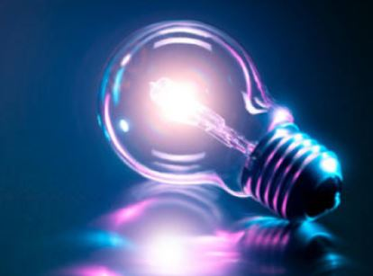

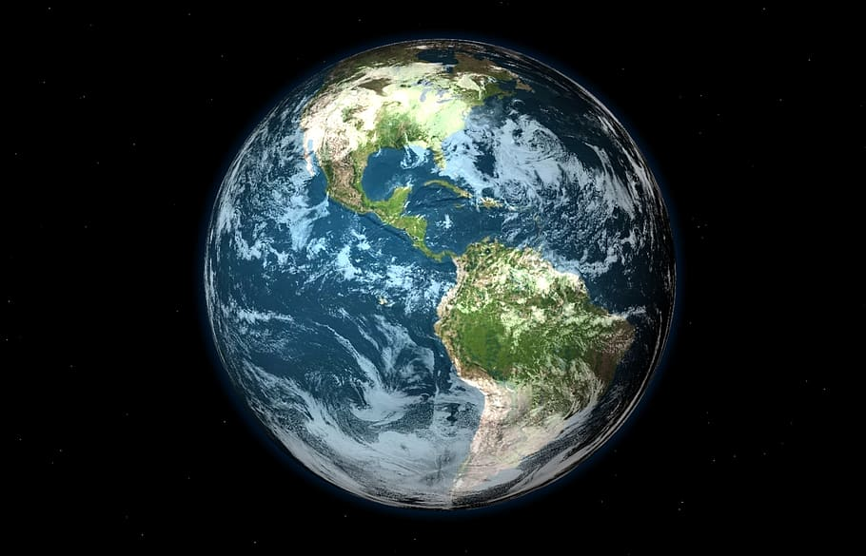

**Hi,**

Welcome to Purple Class! I hope you all have had a restful Summer. I welcome your child to Purple Class and I am sure we will have a fun year of learning.

In class

We have Mrs Dorrian and Mrs Davies as our Teaching Assistants. In addition, Mrs Green will be teaching some lessons on Tuesdays and Art will continue to be taught by the inspirational Mrs Rodgers.

Science

Our Topic this half term is **Electricity.** We will be finding out about how to make a circuit and which materials are good electrical conductors and the dangers too.