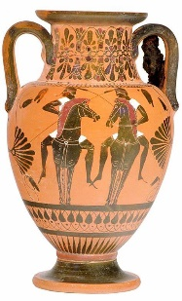
Year 6 Spring 1 Home Learning Project Topic: Ancient Greece
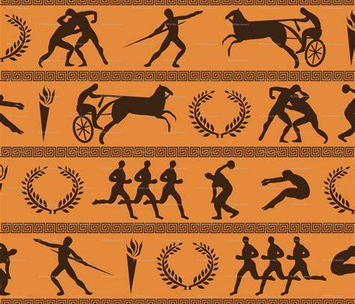
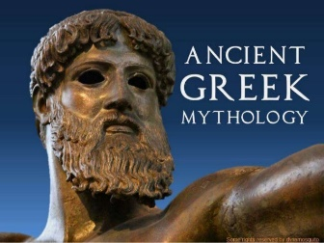
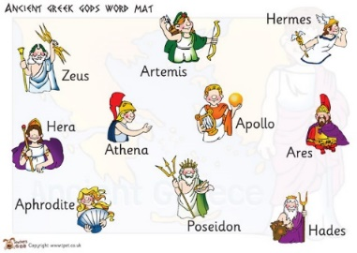
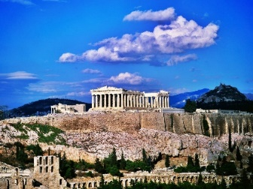

Vases
Myths and Legends
Olympic Games
Gods and Goddesses
The Parthenon

You will need to design and create an Ancient Greece Fact File. This will need to be submitted on Monday 6th February. You might like to include the following information:
- Location in the world (continent, which oceans surround it)
- Historical Celebrities (Alexander the Great – leader; Homer – poet; Pythagoras – scientist)
- Drama and theatre
- Gods and Goddesses
- A day in the life …
- Olympic Games (and other festivals and celebrations)
You can choose how to present your information – will you choose poster, booklet, power point? Within your chosen format, will you include pictures, puzzles, quizzes, or word searches as well as written text. There will be time given during the last week of term to share your Ancient Greece Fact Files and they will be displayed in the classroom.

IMPORTANT NOTICE: Prizes will be given to the most impressive fact files in the following categories:
- Presentation
- Entertainment
- Information

