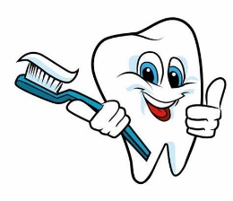
Year 6 Spring 2 Home Learning Project Topic: Healthy Hearts and Bodies
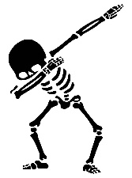
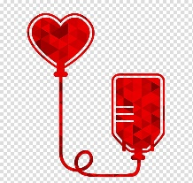
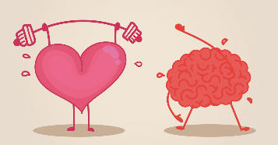

You will need to design and create a Healthy Hearts and Bodies Fact File. This will need to be submitted on Monday 27th March. You might like to include information, diagrams, models or puzzles on the following elements of the human body:
- Skeleton and muscles for protection and movement (Year 3 Science unit)
- Nutrition (Year 3 and Year 6 Science unit)
- Digestive system (Year 4 Science unit)
- Teeth (Year 4 Science unit)
- Changes in the human body from birth through to old age (Year 5 Science unit)
- Heart (Year 6 Science unit)
- Blood and the circulation system (Year 6 Science unit)
- Healthy lifestyles – including water, sleep and exercise (Year 6 Science unit)
You can choose how to present your information – will you choose poster, booklet, power point? Within your chosen format, will you include pictures, puzzles, quizzes, or word searches as well as written text. There will be time given during the last week of term to share your Ancient Greece Fact Files and they will be displayed in the classroom.

IMPORTANT NOTICE: Prizes will be given to the most impressive fact files in the following categories:
- Presentation
- Entertainment
- Information

