**Gold Class Newsletter**

**Spring 2 2023**



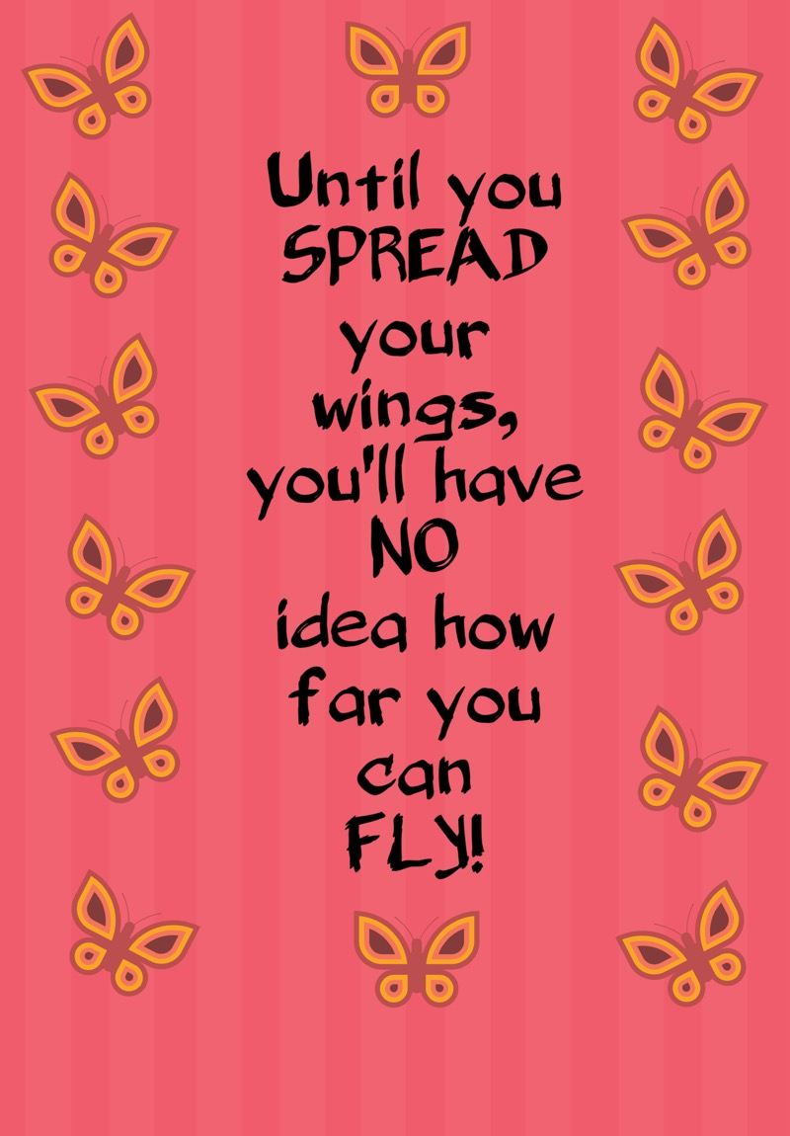

Welcome to Spring 2. I hope you all had a lovely half term!

Inclass

Small groups for Maths and Literacy continue this term, 3 times each week with me, Mr Carrington (literacy) and Mrs Green (maths). Mrs Carrington and Mrs Green will also teach Gold Class every Wednesday as usual this half term. In class, we continue to enjoy working with Miss Wiliams, Mrs Ryan and Mrs Noonan throughout the week.

Punctuality

I would like to offer a polite reminder that our morning gate closes at 8:50 am each day which is when our first lesson starts (this is usually Maths, Literacy or Reading). It is really important that your child is in school on time in the mornings as the registration routine helps to settle us in for a busy day of learning.

Home Learning

Maths and Literacy home learning will continue to be set using the CGP Books. Home learning is set on a Thursday to be handed in the following Tuesday. I always encourage the children to try to find the answer to tricky questions, either asking for support at home, asking google or asking me at school. Thank you for your support in making this such a successful system.

Reading records are due in throughout the week with the expectation that your child has read at least 5 times.

Spellings are also set on google classroom each week, with a test in class every Friday. Spellings are so important. They are a key element of the KS2 writing standards. Learning spellings now is a really good habit to get into and could make the difference between grades at GCSE level in a few years’ time!

All children at Morden are expected to complete weekly practice on their times tables and should be spending 30 minutes each week on TTRS.

*Although this is improving, there are still regularly too many children catching up with times table practice every Tuesday lunchtime as they have not met this home learning expectation. Times tables are so important to all maths learning in Year 6 and beyond. Please support your child to meet the 30-minute TTRS target each week.*

There is also a **home learning project** linked to our Science unit on **Healthy Hearts and Bodies**. Please see project overview sheet for more information.

Congratulations

Well done to the following winners of the Spring 1 Fact File Project on Ancient Greece.

Entertainment: Ajith

Presentation: Kaasiny

Information: Ilona

Wider Curriculum

Please see the website for more information on our Wider Curriculum subjects for this half term.

Dates for your diary

world book day dress up: 28.2.2023

Secondary school offer day: 2.3.2023

Sats PARENTS MEETING: TBC

PARENTS EVENING: 27.3.2023

Easter bonnet parade: 28.3.2023

**Looking forward to a great half term!**

**Mrs Torreiro**