**Gold Class Newsletter**

**Autumn 2 2022**

At home

Please support your child to complete their reading at home each week. 5 signatures are expected each week, showing that your child has read for a period of 20 minutes, 5 times during that week. Developing reading pace and stamina is so important and can make all the difference in the classroom; reading is at the core of all learning.

We also expect children to complete a minimum of 30 minutes on TTRS each week – this is best achieved by practising for 5 minutes each day.

There are also weekly tasks set in the CGP Maths and English home learning books. This continue to be sent home every Thursday to be returned to school the following Tuesday when they will be marked in class. Please encourage your child to ask if there is anything they are unsure about.

In addition to this, spellings will be posted on Google Classrooms every Monday to learn at home. There are weekly tests at school on Fridays.

In addition to this, there is an Home Learning Project. This has a creative writing theme for Autumn 2 and links to our class assembly. Story projects are due in on Monday 13th December – further information is available on Google Classroom. Prizes will be given for presentation, information and entertainment.

Curriculum

Please check out the website for information on our wider curriculum learning journeys in Autumn 2.

Thank you so much for your ongoing support.

**Mrs Torreiro**



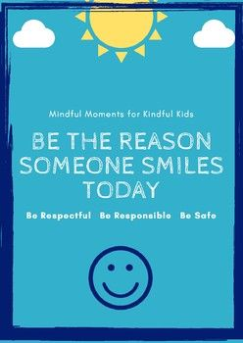

**Hi Gold Class families,**

Welcome to Autumn 2 – the countdown to Christmas. It’s going to be a busy term!

Dates for your diary

November and December will be busy months for Gold Class. As you will know, **11th November** is Remembrance Day and **Gold Class** are very proud to host the **Morden Primary Remembrance Day Assembly**. Please join us at **10:45 am** for this special assembly on **Friday 11th November**, marking the two-minutes silence within our assembly.

We also have a class trip to the cinema as part of the **IntoFilm festival**. We will be watching Sing 2 at the VUE Cinema in Leicester Square on **Thursday 10th November**. Not forgetting the residential trip to **Sayers Croft** from **14th – 18th November**!

Later in the term, KS2 will be joining together as usual to perform our annual **Morden Primary Carol Concert**. This will take place on **Thursday 15th December** in the afternoon at St Lawrence’s Church and we are so pleased to be able to invite you to attend this Christmas Service. Watch out for more information about this event.

We also have Christmas Jumper Days, Christmas Lunches, Christmas Discos and Christmas Parties at school in December – I told you it’s going to be a busy couple of months! More information to follow. Not forgetting the **Christmas Fair** which our PTA are organising for **Saturday 10th December**. You have lots of dates for your diaries before the end of the year. 😊

.