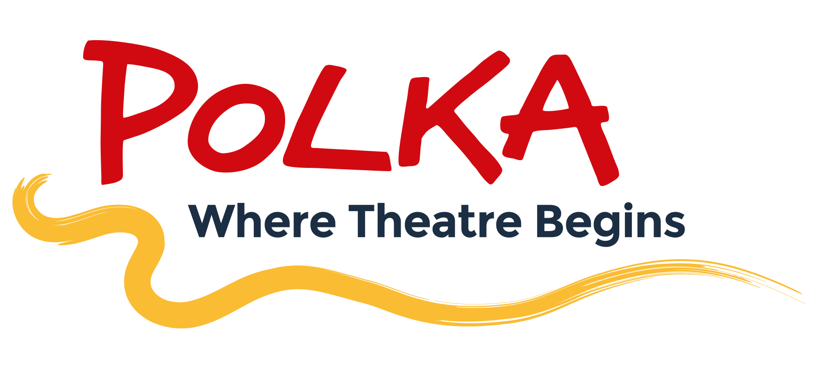

.
4th October 2022
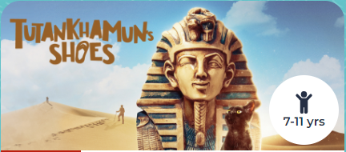

Dear Parents and Carers,

At the end of this half term, Year 6 will be visiting the Polka Theatre for a performance of ‘Tutankhamun’s Shoes’. Tickets have been booked for Friday 21st October at 1:00 pm. This will be a wonderful end to our history topic of Ancient Egyptians and a lovely way to start the half term!

Children will require a packed lunch on the day as we will eat an early lunch in school before making our way to the theatre by public transport.
If you receive free school meals and would like to order a school packed lunch, please email the school at info@morden.merton.sch.uk by Friday 7th October.
After this date you will not be able to order a packed lunch.

We will be back at school by the end of the school day.

Tickets for the show cost £9 and this has been added to your parent pay account. Educational visits are a great opportunity for children to extend their learning beyond the classroom and apply skills they have learnt in school in a different context. School trips also help children to develop the values of responsibility and independence as they learn to represent themselves outside of school.
Please speak in confidence either with myself or Mrs Freeman if you having any financial difficulties in paying for this trip.

It promises to be a great show!

Kind Regards,

Mrs Torreiro
Year 6 Teacher and Phase 3 Leader

