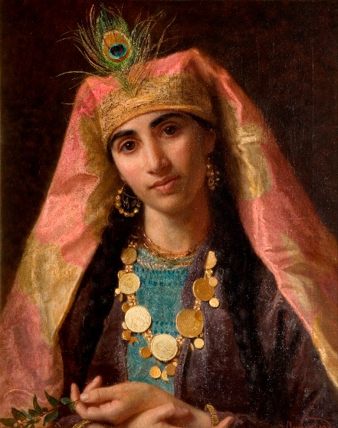
Year 6 Summer 1 Home Learning Project: Creative Writing - 1001 Arabian Nights

Scheherazade
Bedtime stories took on a new meaning for Scheherazade. Her husband, the Sultan, had the nasty habit of marrying a woman at night and killing her in the morning.
So Scheherazade thought up a plan. Every night she would tell him a story, and leave it hanging. 1001 captivating stories later, he decided to keep her.

Sheherazade’s stories included:
The story of Aladdin: A spoiled and lazy youth is taken to a cave by a magician, and once trapped inside, finds a magic lamp inhabited by a jinne (or genie.) By rubbing the lamp, Aladdin is granted any wish he desires, and he eventually wishes his way to wealth and prosperity, all the while pursued by the magician and Aladdin's own brother, who desire the lamp for themselves.
Ali Barbar and the 40 thieves: A poor woodcutter witnesses a group of thieves hiding their stolen treasures in a cave, learning that it will only open if you utter the words "Open Sesame!" Ali Baba visits the cave and takes a small amount of treasure each night until the thieves discover his thefts. They conspire to hide in wood barrels near Ali Baba's home to kill him but are thwarted by a servant named Morgiana, who pours hot oil on their heads and kills them. Ali Baba rewards the servant by offering her his son's hand in marriage, she accepts and the family lives happily ever after, with a cave of treasure at their disposal.
Sinbad the Sailor: Seven different Sinbad tales chart the sailor's adventures on the sea. These tales include highly fantastical locales like an island that is actually a giant whale and an underground kingdom of horses.

Your home learning project for Summer 1 is to write the 1002nd Tale of the Arabian Nights.
Read some of the stories, poems and fables from this collection to find inspiration for your tale.
Try to include all the story-writing features you have learnt in school (e.g. direct speech, powerful descriptions, story vocab).
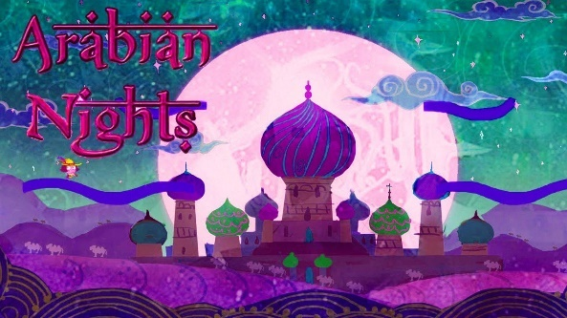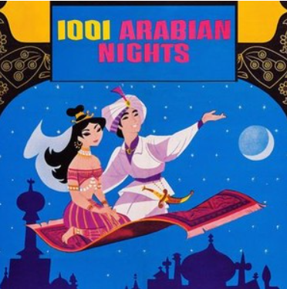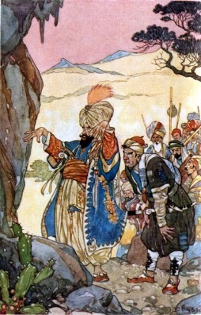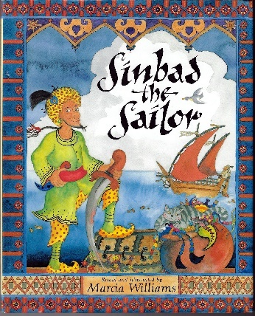
- Where will you set your story? On land? In the ocean?
- When will you set your story? In the past? A modern-day version of an original tale?
- Will you illustrate your story on each page or at key stages?
- What will you call your story?
- Will you write from the point of view of the lead character?
- Will you type or handwrite your story?
Stories will be due in on Monday 22nd May 2023. Prizes will be given for presentation, information and entertainment.

