**Gold Class Newsletter**

**Spring 1 2022**



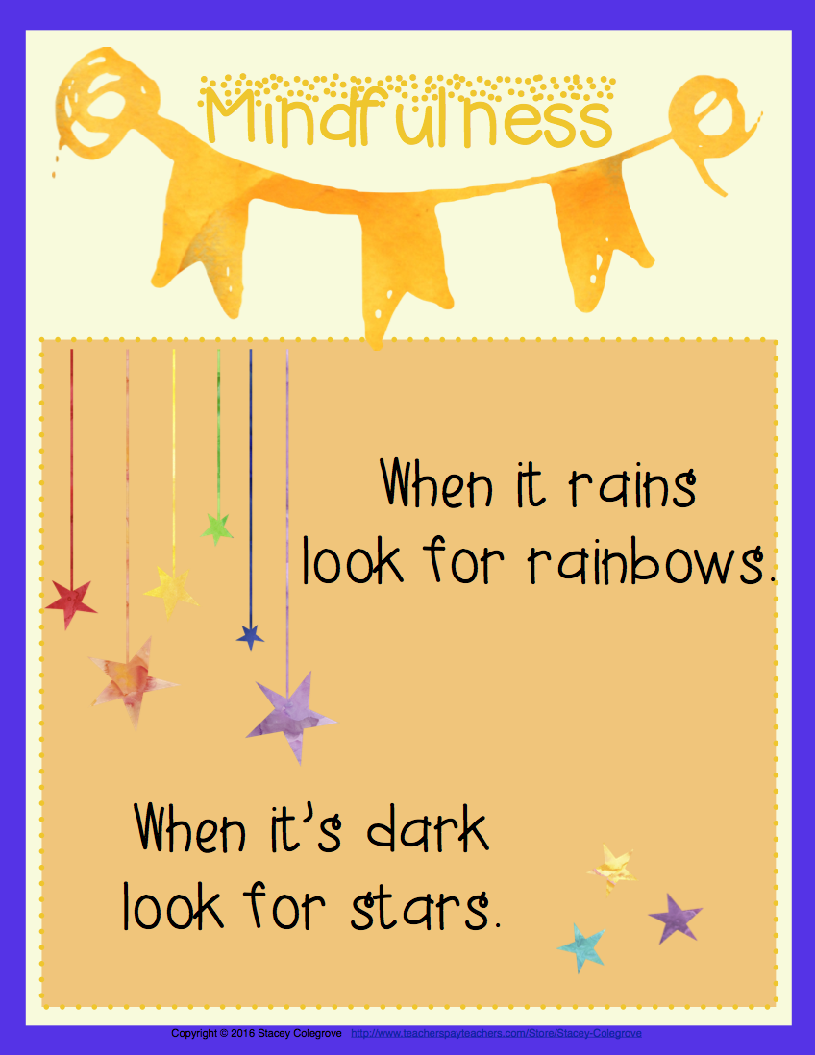

**Happy New Year!** I hope you had a good Christmas break and a have had a happy and healthy start to 2023. Welcome to the Spring term!

Thank you very much for your kind gifts, cards and Christmas wishes at the end of the Autumn Term.

In class

We continue to work with Mr Carrington for literacy groups and Mrs Green for maths groups three times each week in Gold Class. Mr Carrington and Mrs Green will also continue to lead the class every Wednesday to cover my release day.

This term, we say goodbye to Mrs Tapadar in Gold Class as she goes on maternity leave and we wish her all the very best at this exciting time! In Mrs Tapadar’s absence, Miss Williams will work in Year 6 every Friday (in addition to Monday and Tuesday) and Mrs Ryan will work with us every Wednesday and Thursday. Mrs Noonan continues to support us in class every Thursday.

This term, we will start running Booster Classes for maths and reading. Letters will be sent home within the next two weeks if your child is invited to attend.

At home

Maths and Literacy home learning will continue to be set using the CGP Books. Home learning is set on a Thursday to be handed in the following Tuesday. Gold Class are really good at this which is a great learning habit to have developed!

Reading records are due in throughout the week with the expectation that your child has read at least 5 times. Please support your child in completing this reading requirement; reading really does unlock all other learning opportunities.

All children at Morden are expected to complete weekly practice on their times tables and should be spending 30 minutes each week on TTRS.

*However, less than half the class are meeting this home learning expectation regularly and this is something that I would really like to see improved in the new year.*

Even if your child has learnt all their times table badges, they should still be practising their times tables regularly. Multiplication facts underpin all Year 6 maths learning; fluency and speed of recall of times tables make all maths lessons so much easier.

There is also a **home learning project** linked to our History Unit on **Ancient Greece**. Please see project overview sheet for more information.

Congratulations

Well done to the following winners of the Autumn 2 Creative Writing project – *Animal Heroes*.

Entertainment: Kieran

Presentation: Adam

Information: Zara

**Trips**

This will be a quieter term for us in terms of school trips. However, we will be visiting the British Museum later this month to support our literacy and history learning about the Ancient Greeks. Watch out for more details on this.

Wider Curriculum

Please see the website for more information on our Wider Curriculum subjects for this half term.

Thank you for your ongoing support.

**Mrs Torreiro**