Year 6 Autumn 2 Home Learning Project: Creative Writing - Remembrance
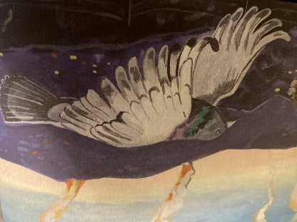
Mary
Some say that cats have nine lives. Perhaps pigeons have even more! During World War 2, a pigeon called Mary of Exeter survived many dangerous missions. Carrying vital wartime messages back to England from the Allied troops in France, this brave bird was often targeted by German hawks, which had been trained to hunt carrier pigeons. Mary also avoided bullets and bombs and even managed to escape when the German air force bombed her home town of Exeter.

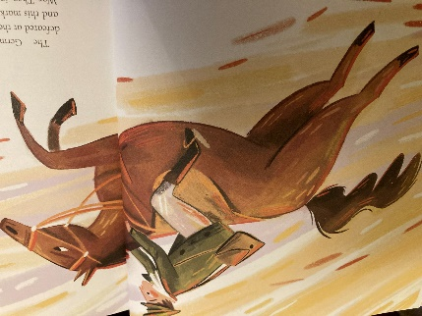
Warrior
Warrior was a chestnut stallion - a horse - from the Isle of Wight who rode into battle with his owner in World War 1. The soldiers all loved Warrior and saw him as their lucky charm. He galloped into battle every day, dodging bullets and explosions and, at times, getting stuck in the mud. Warrior was unlike other animals and did not show fear with the terrifying noises and strange smells. His bravery gave the soldiers the extra courage to face the terrors of war.

Your home learning project for Autumn 2 is to write and illustrate a short story inspired by one of the animal heroes above. Try to include all the story-writing features you have learnt in school (e.g. direct speech, powerful descriptions, story vocab).
- Will you link your story to the Second or First World War? Will you base it on a real story?
- Which animal will you choose?
- Will you illustrate your story on each page or at key stages?
- What will you call your story?
- Will you write from the point of view of the animal or the owner?
- Will you type or handwrite your story?
Stories will be due in on Monday 13th December 2022. Prizes will be given for presentation, information and entertainment.

